# CS 255 System Design Document Template

## UML Diagrams

### UML Use Case Diagram

### UML Activity Diagram

### Login use case activity diagram

### Appointment use case activity diagram

### UML Sequence Diagram

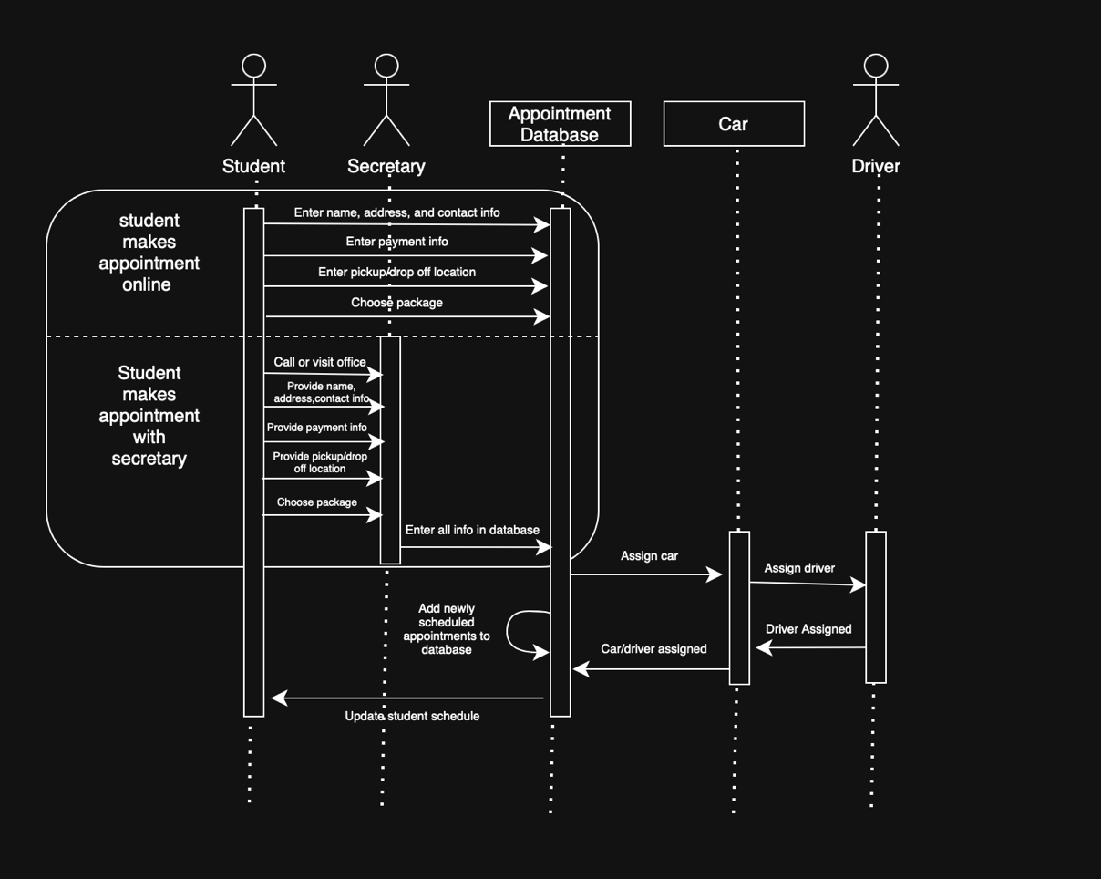

### UML Class Diagram

### 

## Technical Requirements

* Hardware
  + Dedicated Server
  + Internet connection
  + Storage for database and website data
  + Computer or mobile device for user to access website
* Software
  + Windows Server
  + SQL Server for database
  + Backup software for website and database
  + A web server
  + Security software to prevent malware
  + Access to third party payment software